

# **ARDUINO BASED HAND SANITIZER**

A MINI PROJECT

REPORT

*Submitted by*

**NAME OF THE STUDENTS**

ATEEQ UR RAHMAN-1NH18EE704

SRIDHARSHINI-1NH18EE741

SRINJANA CHOUDURY-1NH18EE750

VARUN SHAM KUMAR-1NH18EE753

*In partial fulfilment for the award of the degree of*

BACHELOR OF ENGINEERING

IN

ELECTRICAL AND ELECTRONICS ENGINEERING



**Bonafide Certificate**

This is to Bonafide that the mini project report entitled “**ARDUINO BASED HAND SANITIZER**” submitted by **Ateeq Ur Rahman** bearing **USN:1NH18EE704**, **Sridharshini** bearing **USN:1NH18EE741, Varun Sham Kumar** bearing **USN:1NH18EE753, Srinjana Choudhury** bearing **USN:1NH18EE750** Department of Electrical and Electronics Engineering, New Horizon College of Engineering, Bangalore in partial fulfilment for the award of the degreeof Bachelor of Engineering , is a record of bonafide work carried out by him/her under my supervision, as per the NHCE code of academic and research ethics.

The contents of this report have not been submitted and will not be submitted either in part or in full, for the award of any other degree or diploma in this institute or any other institute or university. The project report fulfils the requirements and regulations of the institution and in my opinion meets the necessary standards for submission.

|  |  |
| --- | --- |
| Guide Name  Guide: LITHESH SIR | Dr. Mahesh.M  HoD |



**Acknowledgement**

With immense pleasure and deep sense of gratitude, I wish to express my sincere thanks to my supervisor **LITHESR SIR**, Professor, Department of Electrical and Electronics Engineering, New Horizon College of Engineering, without her/his motivation and continuous encouragement, this mini project would not have been successfully completed.

I am grateful to the Chairman of New Horizon Educational Institution, **Dr. Mohan Manghnani** for motivating me to carry out research in the NHCE and for providing me with infrastructural facilities and many other resources needed for my project work.

I express my sincere thanks to **Dr.Mahesh.M** HoD, Department of Electrical and Electronics Engineering, New Horizon College of Engineering for his kind words of support and encouragement.

I wish to extend my profound sense of gratitude to my parents for all the sacrifices they made during my project and providing me with moral support and encouragement whenever required.

Date:

Place:

SRIDHARSHINI

ATEEQ UR RAHMAN

VARUN SHAM KUMAR

SRINJANA CHOUDURY

**Index**

**TITLE** PG NO.

**1.0 INTRODUCTION 5**

**2.0 DESCRIPTION 6**

**2.1 WHAT IS AN AUTOMATIC LIQUID DISPENSER? 6**

**2.2 HOW DOES IT WORK? 7**

**2.3 WHY DO WE NEED IT? 8**

**3.0 THEORY 9**

**4.0 COMPONENTS 10**

**4.1 REQUIREMENTS 10**

**i) SENSOR 10**

**ii) MOTOR 12**

**iii) MICROCONTROLLER 14**

**4.2 LIST OF COMPONENTS 16**

**4.3 SUMMARY OF LIST OF COMPONENTS 17**

**5.0 CIRCUIT 18**

**5.1 CIRCUIT DIAGRAM 19**

**5.3 CIRCUIT CONNECTIONS 20**

**6.0 WORKING 21**

**6.1 BLOCK DIAGRAM 21**

**6.2 WORKING PROGRESS 22**

**6.3 CODE 23**

**7.0 PROTOTYPE 25**

**8.0 APPLICATIONS 26**

**9.0 ADVANTAGES 27**

**10.0 PRECAUTIONS 28**

**LIST OF TABLES**

**TITLE PG NO.**

**Table 1.0 11**

**Table 2.0 13**

**Table 3.0 15**

**Table 4.0 17**

**LIST OF FIGURES**

**TITLE PG NO.**

**Figure 1.0 Automatic Liquid Soap Dispenser 6**

**Figure 2.0 Avoid Physical Contact 7**

**Figure 3.0 Sanitize Your Hands 7**

**Figure 4.0 Ultrasonic Sensor 10**

**Figure 5.0 Servo Motor 12**

**Figure 6.0 Arduino Uno 14**

**Figure 7.0 Circuit Diagram 19**

**Figure 8.0 Block Diagram 21**

**Figure 9.0 Code 24**

**Figure 10.0 Prototype 25**

1. **INTRODUCTION:**

* “In this current scenario of global outbreak, it Is advised by WHO to maintain healthy Hand wash and sanitisation habits, but the main problem is the way we do it, that is by physical touch to the bottle, which in short doesn’t serve our purpose.” 000000
* “Keeping in mind the importance of sanitization, the necessity of avoiding physical contact and the affordability of products in these fragile, health endangering, economic crisis-filled times, the group has decided to make the project.” 000000
* “The is an Arduino based hand sanitizer which can automatically dispense the sanitizer without any physical contact. Automatic hand sanitizer dispenser is the quickest way to sanitise your hands. this project is best for proper hand hygiene that can help us stay healthy during these difficult times.” 000000

“

00000000000000000000000000000000000000000

000000

1. **DESCRIPTION:**

**2.1 WHAT IS AN AUTOMATIC LIQUID DISPENSER?**

“An automatic soap dispenser is a device that dispenses a controlled amount of soap solution (or a similar liquid such as a hand sanitizer). They are often used in conjunction with automatic faucets in public restrooms. They function to conserve the amount of soap used and stem infectious disease transmission.” 000000000000

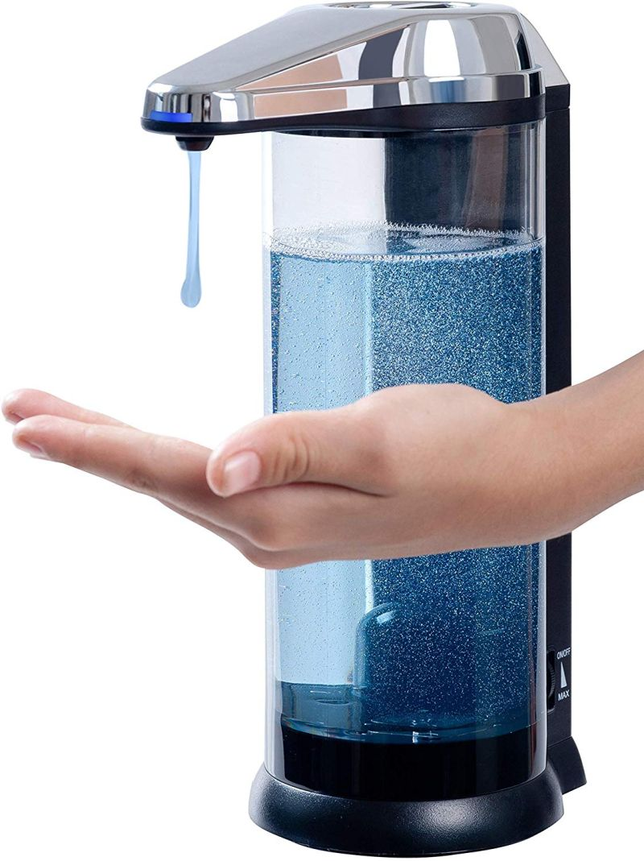

**Figure 1.0 Automatic Liquid Soap Dispenser**000000000000

**2.2 HOW DOES IT WORK?**

“When washing hands, the user’s hands are placed under the nozzle and before the sensor. The activated sensor will further activate a pump that dispenses a premeasured amount of soap from the nozzle. The device uses either of the three sensors mentioned below to detect the object placed in front of the nozzle:” 000000000000

“

* **Radar-based sensor**000000000000
* **Photo sensor**000000000000
* **Passive infrared sensor**000000000000

**“**

**i) RADAR BASED SENSOR:**

“This kind of sensor sends out bursts of microwave or ultrasound energy and waits for the energy to reflect back. In a stagnant situation, the energy will bounce back in a normal pattern. When hands are placed in the basin, the energy emitted from the sensor will bounce back irregularly which triggers the dispensation of soap.” 000000000000

**ii) PHOTO SENSOR:**

“This mechanism is composed of two parts, a source of focused light (usually a laser beam) and a light sensor. When the user’s hands are placed in line of the beam of light, the pump mechanism is activated by the disruption that is sensed by the light sensor.” 000000000000

**iii) PASSIVE INFRARED SENSOR:**

“Infrared sensors detect infrared energy that is emitted by one’s body heat. When hands are placed in the proximity of the sensor, the infrared energy quickly fluctuates. This fluctuation triggers the pump to activate and dispense the designated amount of soap.” 000000000000

**2.3 WHY DO WE NEED IT?**

“In present times, especially with speculations of a new strain of the coronavirus around the world, we need to take utmost measures of safety and sanitisation. But even while sanitising, we need to make sure that we do not have physical contact with objects which are used by more than one person, in this case, a hand wash/ hand sanitizer container nozzle. This project ensure that we avoid such physical contact by automatically dispensing hand sanitizer after detecting an object (your hand) which is placed under it. “000000000000



**Figure 2.0 Avoid Physical Contact**000000000000

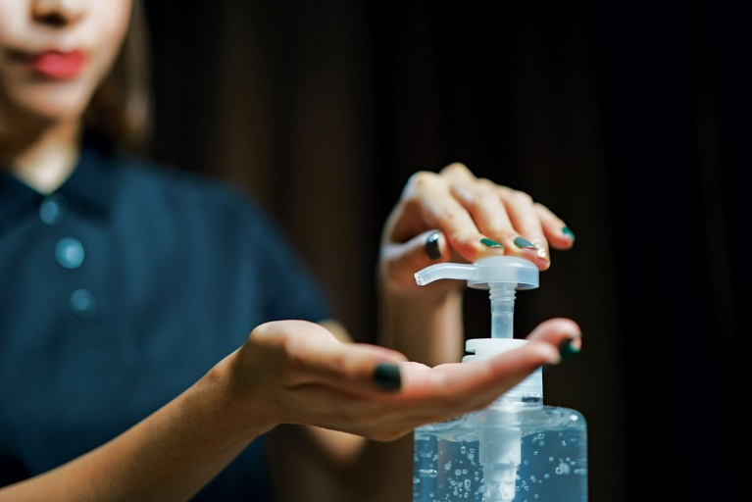

**Figure 3.0 Sanitize Your Hands** 000000000000

**3.0 THEORY:**

“The project uses a mechanismwhich will create a force to push the nozzle down and dispense the liquid, since we are using servo motor, that provides circular motion, it alone can’t create a downwards force, we will need some kind of mechanical arrangement to make it happen, we will use pulley mechanism to fix one end and convert the rotational force to push, we can do that using Copper Wire to create a downwards vector force for transmission, what it basically does is, it convert the circular force of Servo to a downwards acting force vector, to simulate push.”

**4.0 COMPONENTS:**

**4.1 REQUIREMENTS:**

**i) SENSOR:** 000000000000000000000000

“We will need a Sensor to sense our proximity or presence which will basically act as a trigger or touch less switch for this system. We have two choices here, that is we can use either IR sensor Module, or Ultrasonic Sensor Module. We can use IR sensor Module, which is basically a cheap and efficient option, but sometimes inaccurate, or we can use HC-SR04 Ultrasonic sensor, which is quite accurate above 2 cm range, and slightly expensive option, but we will use Ultrasonic Sensor for this Tutorial, for better accuracy.” 000000

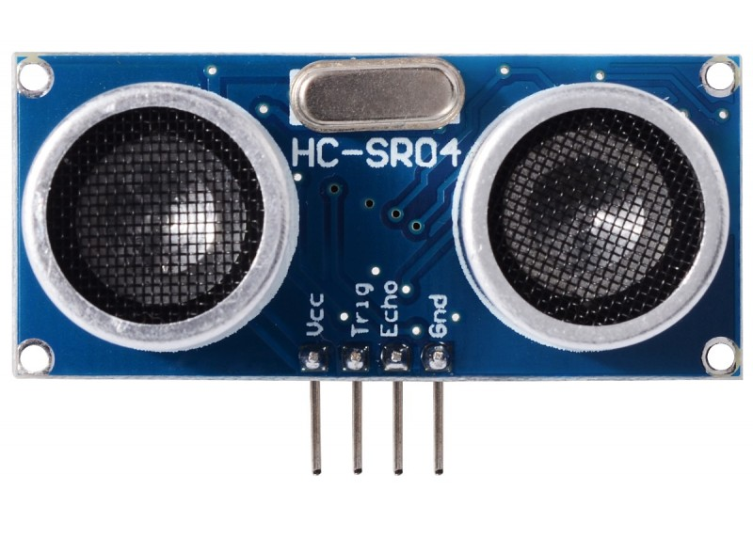

**Figure 4.0 Ultrasonic Sensor HC-SR04**

**CHARACTERISTICS OF ULTRASONIC SENSOR:**

“The Reflective Ultrasonic Sensor (Distance-adjustable or Zone-setting Convergent Reflective Sensor) sends ultrasonic waves from an emitter toward a sensing object, then receives the reflected waves with a detector. The Sensor uses the resulting information to determine the presence of an object, or to measure the distance to the object. This type of Sensor determines the distance from the Sensor to an object based on the time required from when the ultrasonic waves are sent until they are received using the speed of sound. There are also Through-beam Sensors that detect the presence of an object by detecting the attenuation or interrupted condition of ultrasonic waves caused by an object passing between the emitter and detector.” 000000

**“**

|  |  |
| --- | --- |
| Input Voltage | 5V |
| Current Draw | 20mA (Max) |
| Digital Output | 5V |
| Digital Output | 0V (Low) |
| Working Temperature | -15°C to 70°C |
| Sensing Angle | 30° Cone |
| Angle of Effect | 15° Cone |
| Ultrasonic Frequency | 40kHz |
| Range | 2cm - 400cm |

**“**

**Table 1.0**

**ii) MOTOR:** 000000000000000000000000

“For motion or to process the Output, we might need either a pump, either motor, or some electronic component that will convert electrical signal to mechanical displacement of alcohol based hand rub or sanitizer through the dispenser, best choice would be to use a Servo motor with metal gears for maximum torque. We will avoid using micro pumps, since they are to be inserted into the container, which again creates vulnerable containment spot. So using an external mechanism with help of servo would be a wise choice.” 000000000000

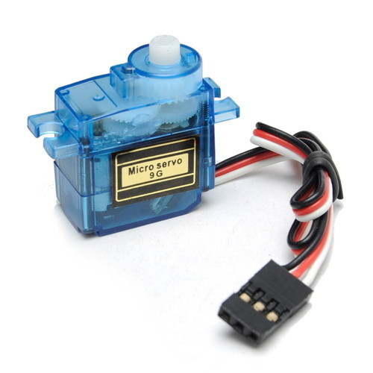

**Figure 5.0 Servo Motor**

**CHARACTERISITICS OF SERVO MOTOR:**

“Servo motors are able to operate at a wide range of speeds—both high and low—without overheating, and to maintain sufficient torque at zero speed to hold a load in place. They can also maintain a constant velocity, despite changes in the amount of torque acting on the system.” 000000000000

“Torque control is also possible with a servo motor, and servos are often defined by their speed-torque curves, which indicate the motor’s peak and continuous torque values. Peak torque is the maximum torque the motor can generate for a short amount of time, while continuous torque can be produced indefinitely. If a servo motor is operated above its continuous torque rating for a significant amount of time, excess heat is generated, which will damage the motor’s circuitry. Operating a servo motor above its peak torque can demagnetize the magnets.” 000000000000

**“**

|  |  |
| --- | --- |
| Model | SG90 |
| Weight | 9 gm |
| Operating voltage | 3.0V~ 7.2V |
| Servo Plug | JR |
| Stall torque @4.8V | 1.2kg-cm |
| Stall torque @6.6V | 1.6kg-cm |

**“**

**Table 2.0**

**iii) MICROCONTROLLER:** 000000000000000000

“For this project build, we will need a Microcontroller to control the Input and Output, to Calculate the distance or sense the Trigger from Sensor and Process the Output in form of Servo Sweep in our Example, for which we can use any Arduino, which makes it easy to adjust the parameters, fine tune outputs, so you can use any Arduino, we will use Arduino Uno for our work case.” 000000000000

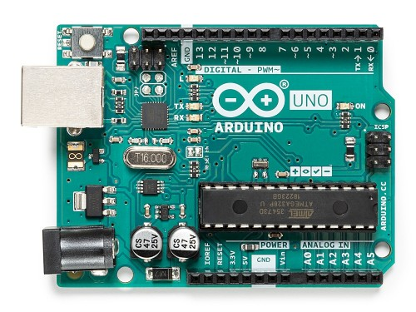

**Figure 6.0 Arduino Uno**

**CHARACTERISTICS OF ARDUINO UNO:**

“The Arduino Uno is a microcontroller board based on the ATmega328 (datasheet). It has 14 digital input/output pins (of which 6 can be used as PWM outputs), 6 analog inputs, a 16 MHz ceramic resonator, a USB connection, a power jack, an ICSP header, and a reset button. It contains everything needed to support the microcontroller; simply connect it to a computer with a USB cable or power it with a AC-to-DC adapter or battery to get started. The Uno differs from all preceding boards in that it does not use the FTDI USB-to-serial driver chip. Instead, it features the Atmega16U2 (Atmega8U2 up to version R2) programmed as a USB-to-serial converter.” 000000000000

“

|  |  |
| --- | --- |
| Microcontroller | ATmega328 |
| Operating Voltage | 5V |
| Input Voltage (recommended) | 7-12V |
| Input Voltage (limits) | 6-20V |
| Digital I/O Pins | 14 (of which 6 provide PWM output) |
| DC Current per I/O Pin | 40 mA |
| Analog Input Pins | 6 |
| DC Current for 3.3V Pin | 50 mA |
| Flash Memory | 32 KB (ATmega328) of which 0.5 KB used by bootloader |
| SRAM | 2 KB (ATmega328) |
| EEPROM | 1 KB (ATmega328) |
| Clock Speed | 16 MHz |

**“**

**Table 3.0**

**4.2 LIST OF COMPONENTS:**

**“Electronics:**

**“**

* Arduino Uno000000
* Ultrasonic Sensor (HC-SR04) 000000
* Servo Motor.000000000000
* Jumper Wires. “000000

“

**“Tools:**

**“**

* Hot Glue Gun/ Double Sided Tape. 000000000000
* Computer or Laptop. 000000” 000000

“”

**“Miscellaneous:**

**“**

* Alcohol Based Hand Rub or Sanitizer. 000000000000
* Self-Threading Screw (1 pcs). 000000000000
* 0.8 mm copper wire (0.5 meters). 000000000000
* Plastic container. 000000000000
* Stationary (marker and ruler scale). 000000” 000000

**4.3 SUMMARY OF LIST OF COMPONENTS:**

**“**

|  |  |
| --- | --- |
| COMPONENT | QTY |
| ARDUINO | 1 |
| SERVO MOTOR | 1 |
| ULTRA-SONIC SENSOR | 1 |
| JUMPER WIRES | AS PER REQUIRED |
| MISCELLANEOUS | AS PER REQUIRED |

**“**

**Table 4.0**

000000000000000000000000000000

**5.0 CIRCUIT:**

**5.1 CIRCUIT DIAGRAM:**

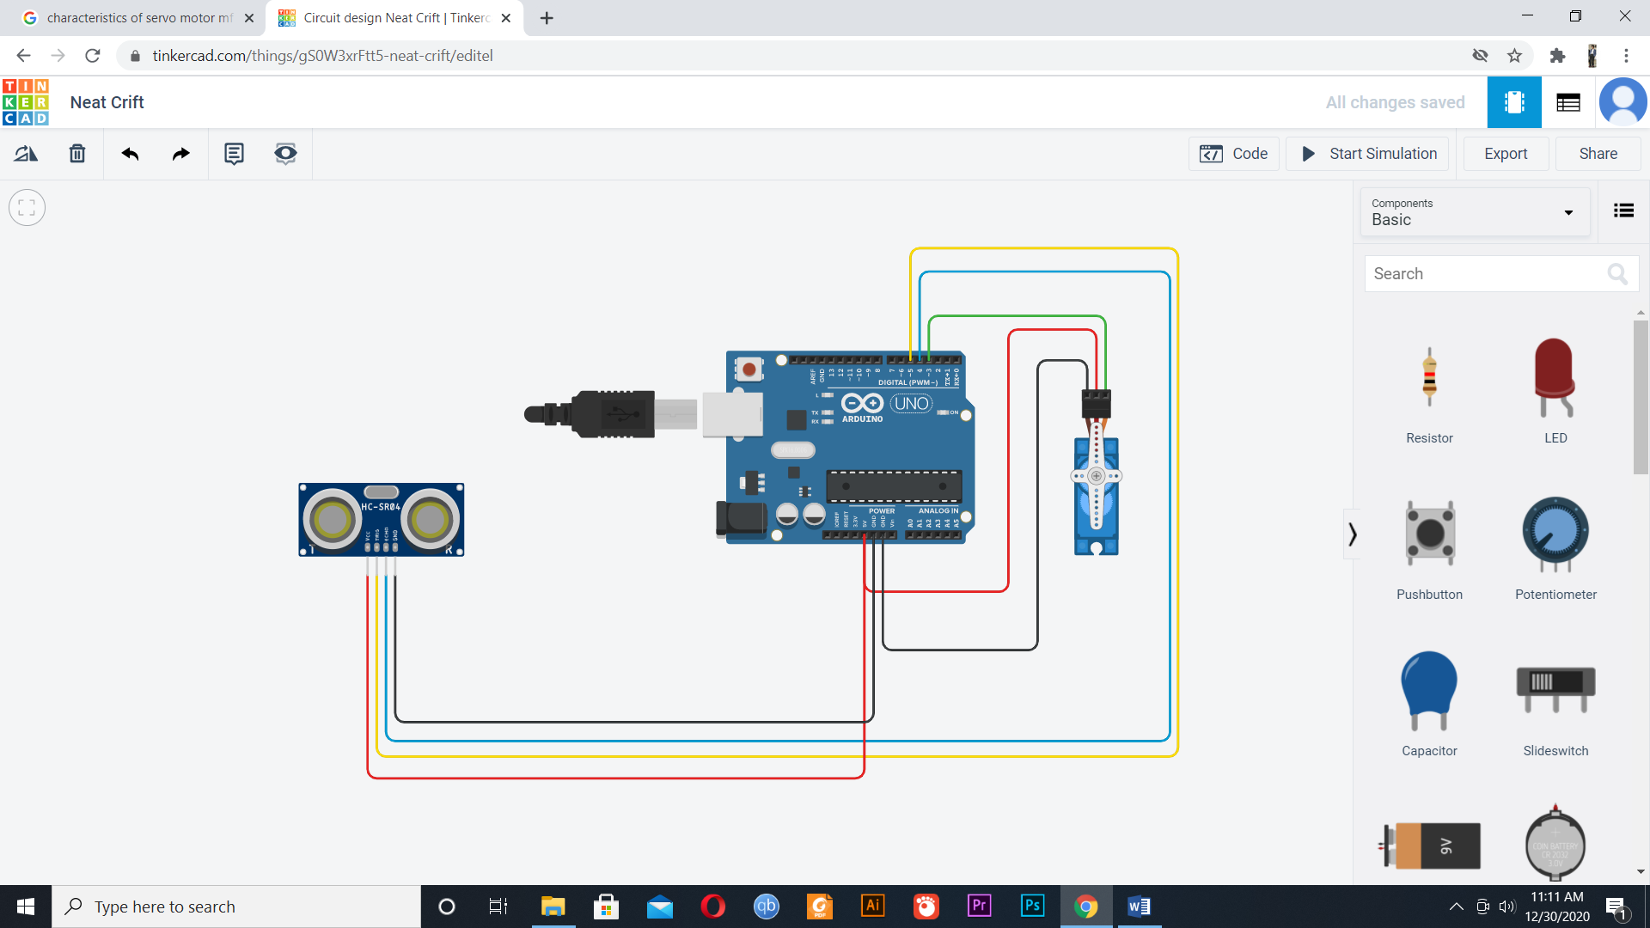

**Figure 7.0 Circuit Diagram**

**5.2 CIRCUIT CONNECTIONS:**

**“Sensor to Arduino:**

**“**

* Trigger to D500000000000000
* Echo to D4000000
* Vcc to 5v000000
* Gnd to Gnd000000

“”“

**“Servo to Arduino:**

**“**

* Signal to D3000000
* Vcc to 5v000000
* Gnd to Gnd000000

“

000000000000000000000000000000000000000000

**6.0 WORKING:**

**6.1 BLOCK DIAGRAM:**



**Figure 8.0 Block diagram**

000000000000000000000000000000000000000000000000000000

000000000000000000000000

000000000000000000000000

**6.2 WORKING PROCESS:**

* “Here, we use an Ultrasonic distance sensor, Servo motor and Arduino board. When we place our hand in front of the distance sensor, it will help to the Arduino to measure the distance from the sensor to object (here the hand). if the object in the desired range, Arduino will write the servo to 180. Servo motor is mounded on the hand sanitizer bottle. And the trigger of bottle is connected to servo by a thread. When servo motor rotate, the trigger will press.” 000000
* “When an object (your hand) is within 10cm from the Ultrasonic Sensor, it sends a signal to the Arduino. The Arduino then sends a signal to the Servo motor which then starts rotating. The rotation of the motor causes tension in the Copper wire which is bounded around the servo motor at one end and around a screw at the other end. The tension in the wire causes a downward force to occur and hence the round object attached to the wire pushes down the nozzle of the plastic container which contains the Sanitizer.” 000000
* “When the object is moved away from the desired range, the servo motor rotates back to its initial position. Thus the wire, which is relieve off its tension, returns to its initial position and so does the nozzle of the container.” 000000

000000000000000000000000

000000000000

**6.3 CODE:**

“”””

#include<Servo.h>000000

#define echoPin 4000000

#define trigPin 5000000

Servo Myservo; 000000

int long duration; 000000

int distance; 000000

void setup(){ 000000

Myservo.attach(3); 000000

pinMode(echoPin,INPUT); 000000

pinMode(trigPin,OUTPUT); 000000

}000000

void loop()

{000000

digitalWrite(trigPin,LOW); 000000

delayMicroseconds(2); 000000

digitalWrite(trigPin,HIGH); 000000

delayMicroseconds(10); 000000

digitalWrite(trigPin,LOW); 000000

duration=pulseIn(echoPin,HIGH); 000000

distance=(duration*0.034/2); 000000

if(distance<=10) {000000

Myservo.write(180); 000000

}000000

else {000000

Myservo.write(0); 000000

}000000

delay(500); 000000

}000000”

“

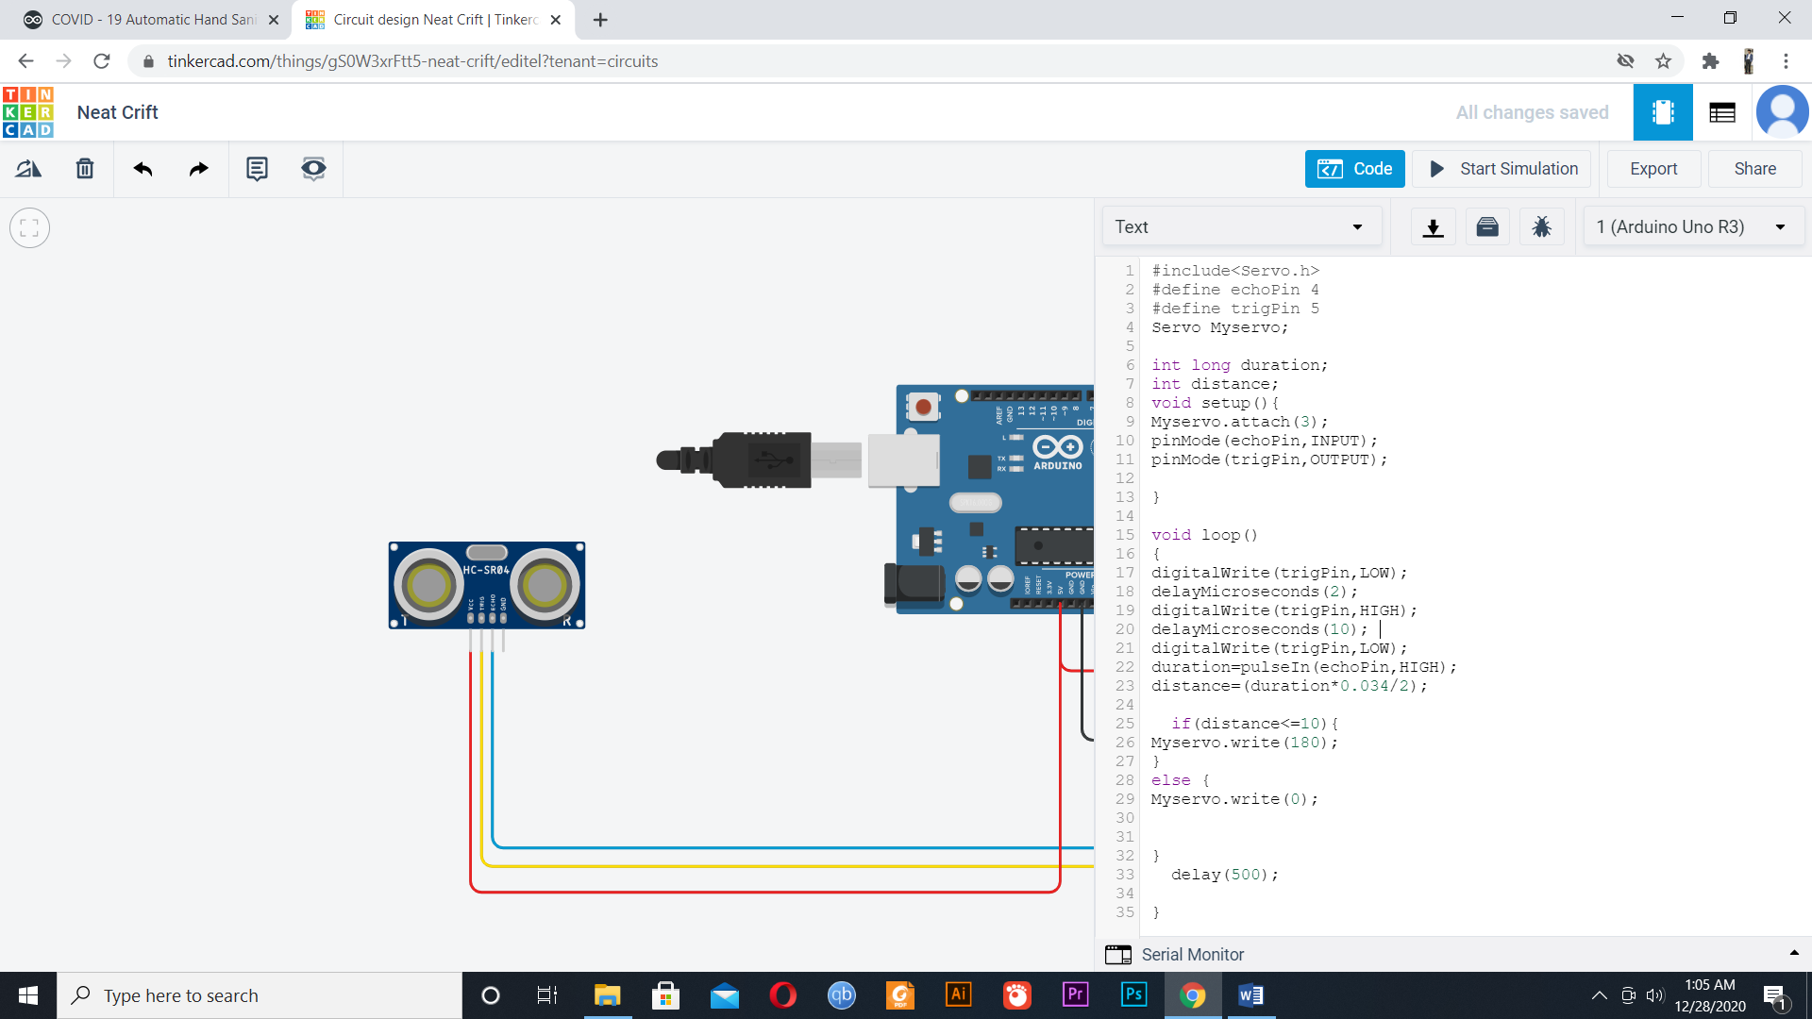

**Figure 9.0 Code**000000000000000000000000000000000000000000000000000000000000

“

**7.0 PROTOTYPE:**

**“**

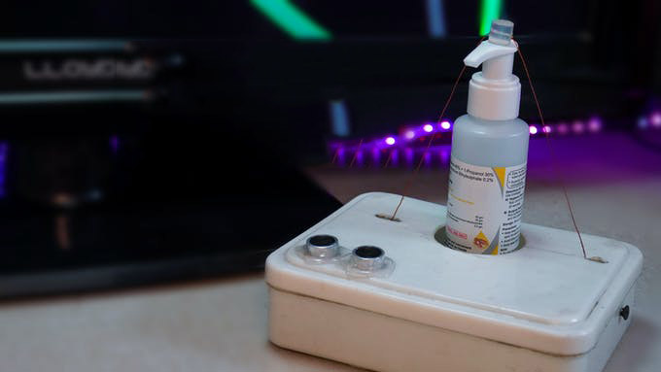

**Figure 10.0 Prototype”**

**8.0 APPLICATIONS:**

**“**

* Automatic germicide/hand wash dispensers at home
* Automatic germicide/hand wash dispensers at hospitals
* Automatic germicide/hand wash dispensers at college
* Automatic germicide/hand wash dispensers at offices
* Automatic germicide/hand wash dispensers at stores

“

**9.0 ADVANTAGES:**

**“**

* Affordable
* Easy to use
* Easy to maintain
* Can be made at home
* Versatile
* Touchless

“

**10.0 PRECAUTIONS:**

**“**

* Cover the upper part of the container to prevent the circuit from external damage
* Stay cautious while using hot glue.
* Do not hold your hand under the nozzle for longer than required.
* Stay cautious while using the screw.
* Avoid liquid from contacting the circuit.

“